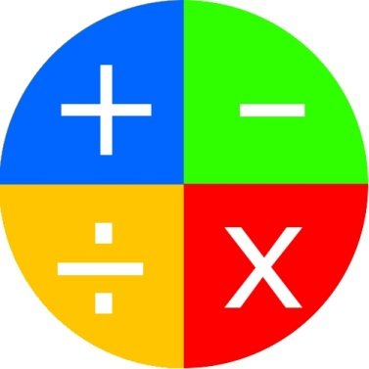 **Red Hats present:**

**Math Racer**

**The Pain Point**

Practising mathematics just isn’t fun, solving meaningless problem after problem for the sake of getting better at the problems, so we’re adding a little motivation to an otherwise menial task.

**How do we solve the issue?**

We fix the issue by hiding the boring repetition of practising math behind a competitive atmosphere; it’s no longer a case of completing a sheet of problems for homework, now you work towards being the best, the fastest. We achieved this using peer motivation; every set of problems is now a race against other players.

**Target Audience:** Primary school students

Screen cap here

**Scale:** 100 concurrent users

**Scope:** National

**Key features and why they make Math Racer better than the rest**

**A competitive environment**

Math Racer offers peer to peer competition, all games consist of two or more players going head to head in real time. Competitors like <http://www.sheppardsoftware.com/math.htm> only let you compete against the clock. Offering player versus player interaction means that users are more engaged and more likely to play again.

**Stat tracking**

Math Racer keeps track of how well you’ve been doing and gives you access to useful metrics to see how you’ve been improving. Other sites such as <http://www.math-play.com/> only offer a disjoint selection of flash games with no sense of progress or improvement. Tracking progress motivates users with the sense of accomplishment they can see for themselves that they are improving.

Screen caps here